Create two datasets employee and department of file type text where the columns are delimited by tab (‘\t’), and use these datasets to perform below Join operations

**EMPLOYEE AND DEPARTMENT DATASET**

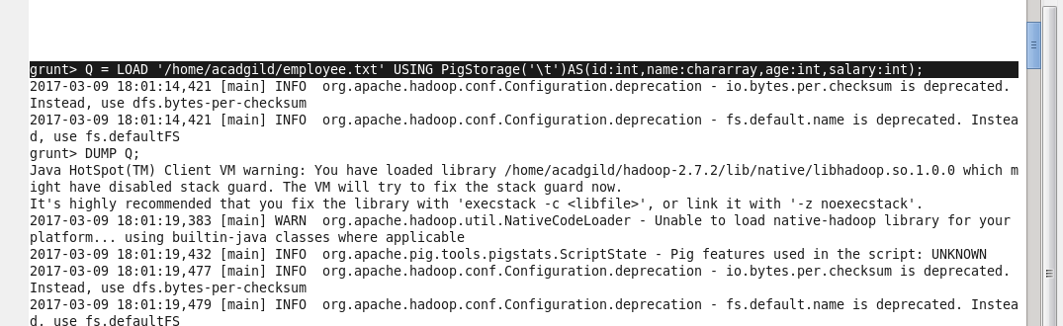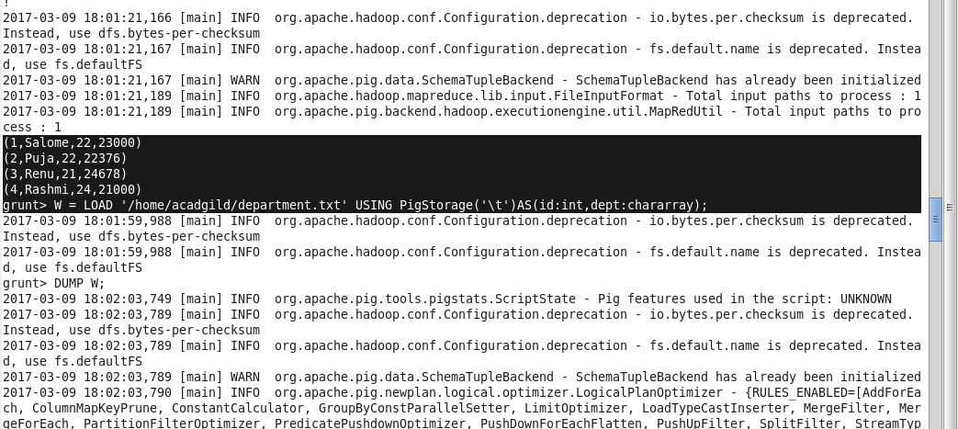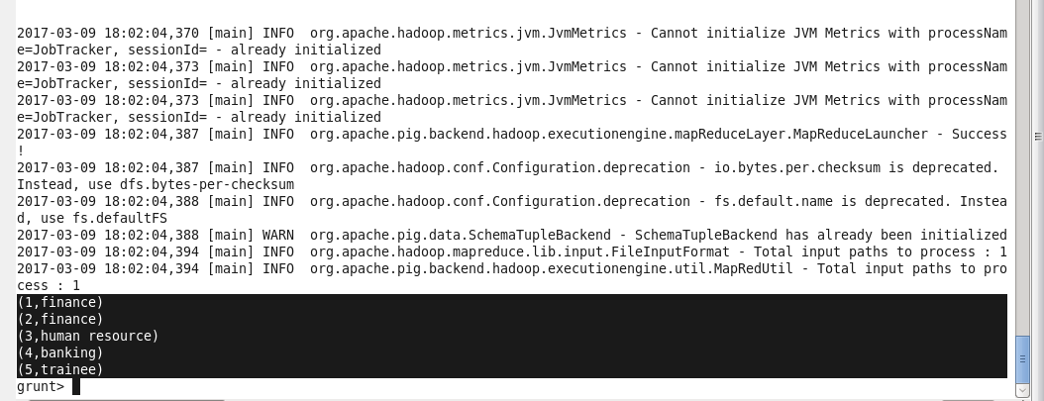

**SELF JOIN:** 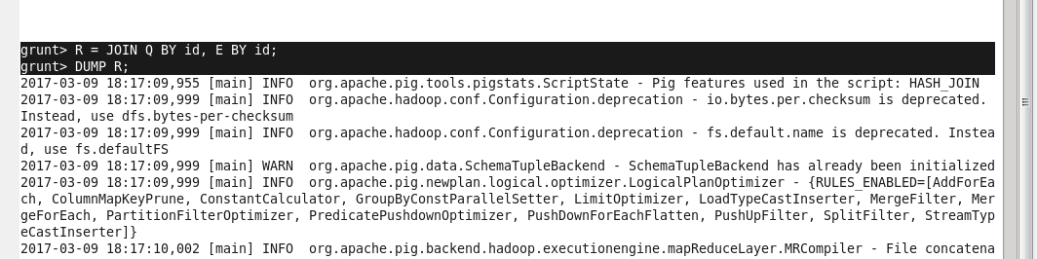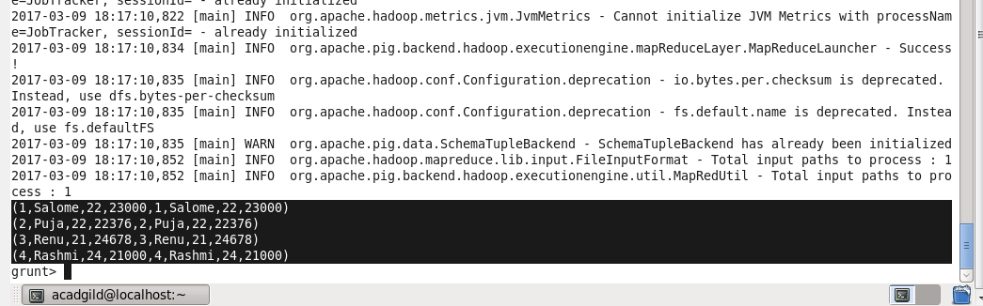

FGDFHGHGHGHGFG

**LEFT OUTER JOIN**

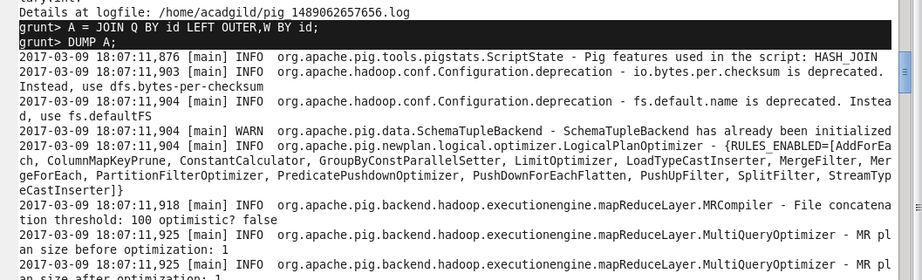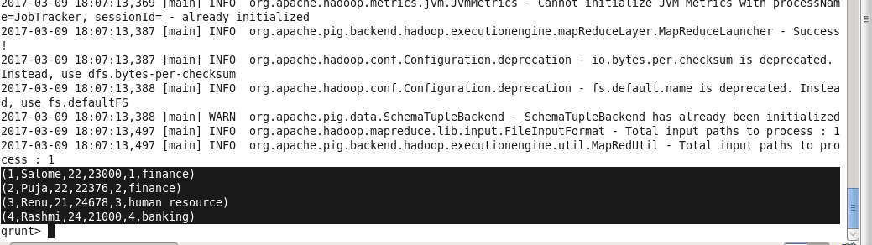

**RIGHT OUTER JOIN**

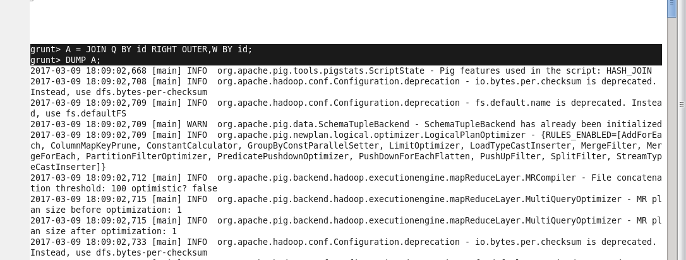

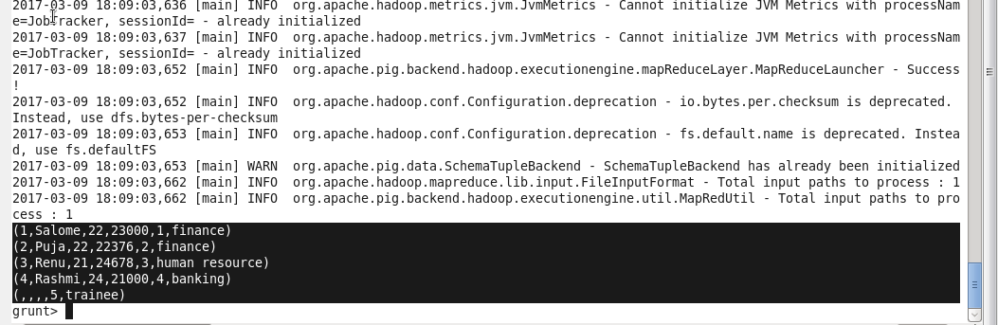

**FULL OUTER JOIN**

